EENG 385 - Electronic Devices and Circuits

Lab 1 - Introduction to Multisim and the 555-timer

Lab Handout

# Objective

There are two main objectives of this lab; introduce you to the Multisim Live tool. You will use the Multisim Live tool throughout the remainder of the term, to test circuit ideas before building them

# Using Multisim Live: Navigating the interface

You will be using Multisim Live through the remainder of the term. When you login, you should be taken directly to your profile area see Figure 2. However, if this is not the case, you can get to your profile by clicking on My Profile (circled in red in Figure 1) under the pull-down menu associated with your Multisim Live profile name.

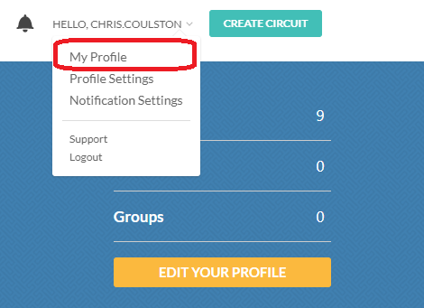

Figure : You can access your profile using the dropdown menu associated with your profile name.

Your profile area, shown in Figure 2, contains all your designs. Here you will either select a design to edit (click on tile circled in blue), or create a new circuit (click on turquoise button circled in red).

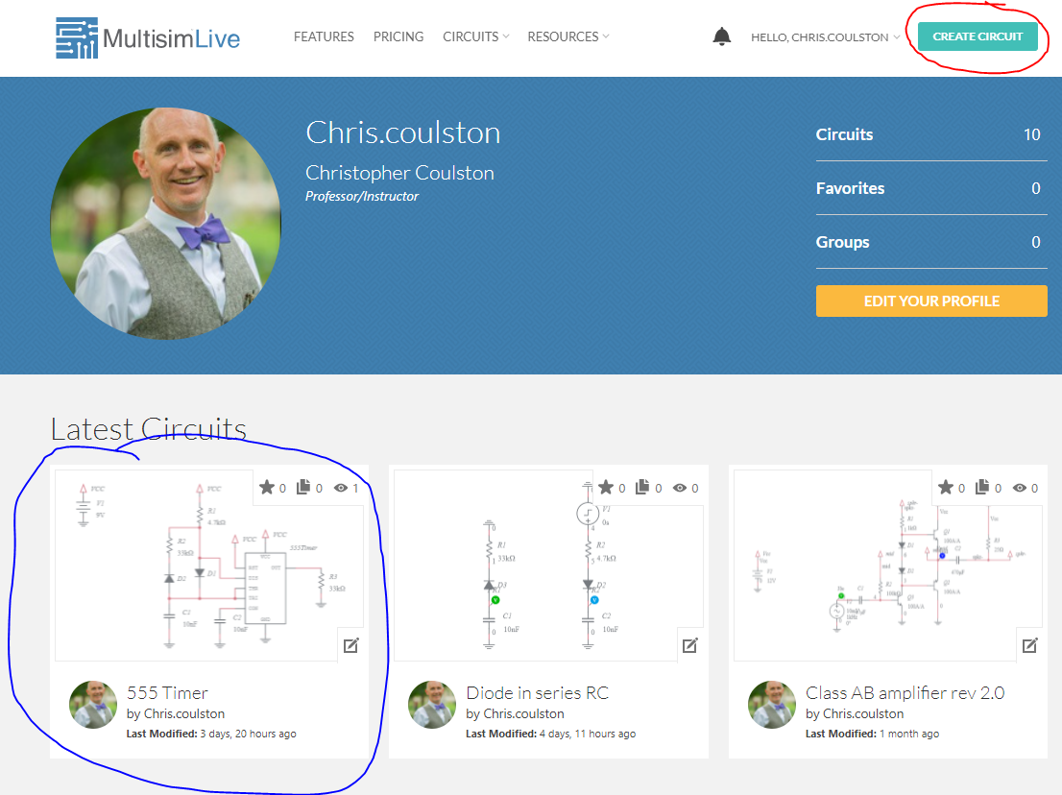

Figure : The Multisim Live interface as it appears when you login.

When you select an existing circuit from your profile, you will be sent to an intermediate page which has file maintenance option; most likely you will want to click on click on turquoise OPEN CIRCUIT button, which will take you to the schematic-entry view of your circuit shown in Figure 3.

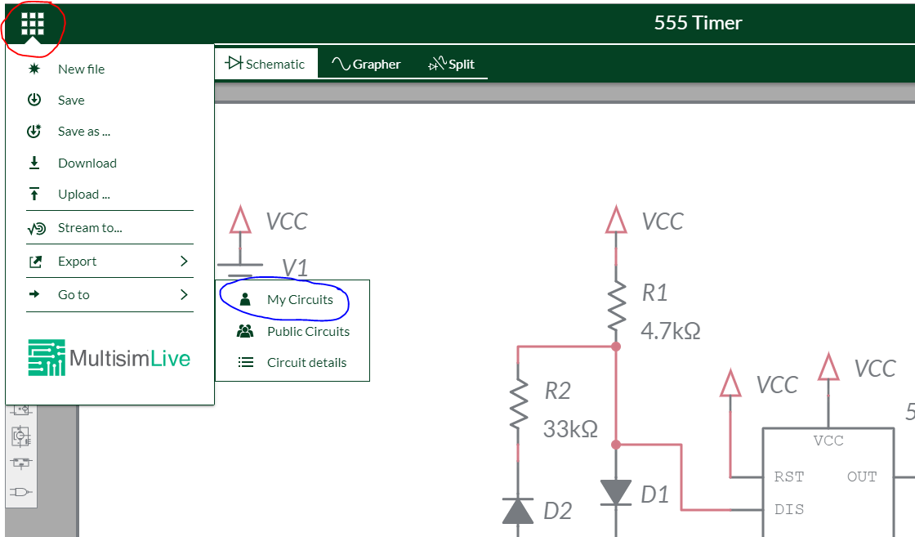

Figure : The schematic view of a circuit and the button clicks to return to your profile.

The 3x3 grid of tiles in the upper left corner of the schematic-entry screen (circled in red in Figure 3) is a well disguised menu that you can use to save your file (please save frequently) and return back to the profile page (circled in blue in Figure 3). Please take a moment to experiment with both the profile and schematic entry before proceeding.

# Using Multisim Live: Building a circuit

Let’s build the 555-timer circuit that we analyzed in the previous section. Start this process by creating a new circuit from your profile page. Then work through the following steps to create your schematic.

1. You should see the schematic-entry page in Figure 4; the names of the different tools are shown in red text adjacent to each tool. You will see these names pop-up when you allow your mouse pointer to loiter over a tool.

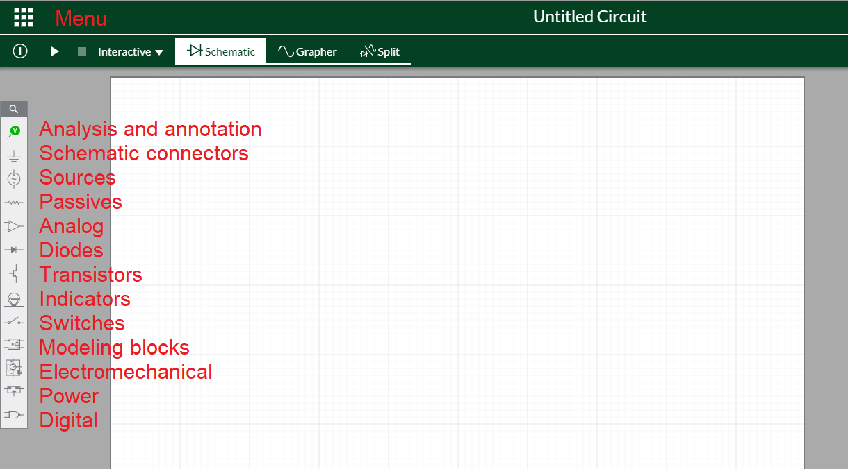

Figure : The names of the different components available to build a circuit are shown in red.

1. Try using the scroll wheel on your mouse to zoom-in and zoom-out. Try left clicking on a blank area of the screen and panning left/right/up/down across the schematic.
2. Let’s start by building the power supply subsystem circled in red in Figure 5.

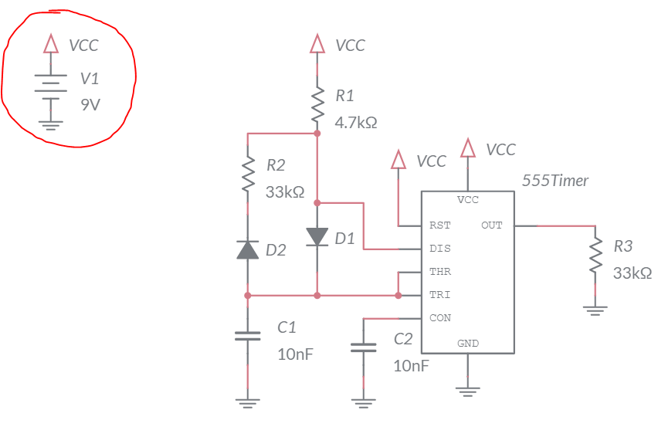

Figure : The 555-timer circuit with the power supply subsystem circled in red.

1. Go to the Sources tool (see Figure 4) and select DC Voltage (VCC).
2. Your mouse pointer will look like the DC Voltage symbol. Left mouse click to drop an instance of the DC Voltage on your schematic. You will see the DC Voltage symbol surrounded by four controls. As with the tools menu, loitering over each control will reveal its name. These controls will appear whenever you select the component. I often use the Duplicate tool to create copies of common components like resistors. Experiment with the Flip and Rotate tools to see how the affect the DC Voltage symbol.

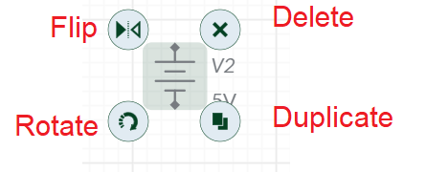

1. Double click on the DC Voltage symbol to reveal the properties menu on the right side of the screen,
2. Change the DC_mag field to 9. This will set the DC Voltage symbol to create a 9 V potential between its terminals. If you wanted to the DC Voltage symbol to be 9mV then you would enter 9m in the DC_mag field,
3. Click on the Schematic connector tool and select Connector,
4. Place the Connector on top of the DC Voltage symbol so the bottom of the connector symbol has a small gap to the top of the DC Voltage symbol,
5. Change the IC property of the Connector to VCC. Note, any other Connectors in the schematic named VCC will be attached to this Connector and consequently to 9V.
6. Click on the Schematic connector tool and select Ground,
7. Place the Ground symbol on the bottom of the DC Voltage symbol so the top of the Ground symbol has a small gap to the bottom of the DC Voltage symbol.
8. You should have something that looks like the following image. Place your cursor over the GND terminal (circled in red). The hand icon for the mouse pointer should change into a wire-spool icon. This indicates that you can wire together components.

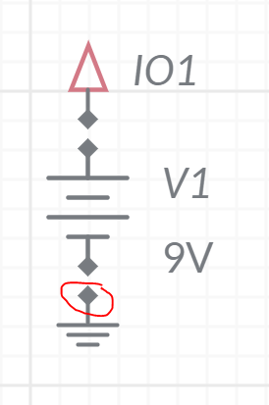

1. Left click on the GND terminal, move the cursor to the lower DC voltage supply terminal and left click. There should now be a red wire connecting the two terminals.
2. Connect the VCC connector to the upper DC voltage supply terminal. You should now have something like the following.

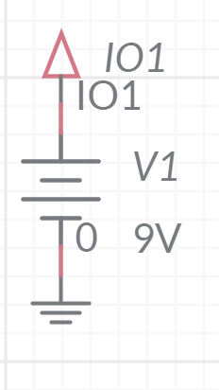

1. Note, I like to see small segments of red wire between connected components. This reassures me that they components are in fact connected.
2. Complete the schematic. You will find the components using the information listed in the table below. Experiment with the different editing tools (copy, rotate, delete). Also, make sure to give the resistors and capacitors the correct values.

|  |  |  |
| --- | --- | --- |
| Component | Tool | Name |
| DC Voltage Supply | Sources | DC Voltage |
| Ground | Schematic connectors | Ground |
| VCC | Schematic connectors | Connector |
| Resistor | Passive | Resistor |
| Capacitor | Passive | Capacitor |
| Diode | Diodes | Diode |
| 555 Timer | Analog | 555 Timer |

# Save your file. Click on the 3x3 grid of squares in the upper left corner and select “Save”. In the “Save as a new circuit” pop-up, type “lab01 555-timer” and provide a meaningful description, something like: “A 555-timer that generates a waveform”.

# Using Multisim Live: Simulating a circuit

Now that you have created a circuit it’s time to simulate it so that you can make sure that it functions and behaves as expected.

1. Start by clicking on the Analysis and annotation tool and placing a Voltage probe on the out signal from the 555-timer (circled in red in Figure 6). This probe will measure the voltage on the out pin and record it in the timing window, much like an oscilloscope.
2. Click on the Split control (circled in fuchsia in Figure 6) to get a split the screen between the schematic and the timing windows.
3. Click on the white background of the schematic so that you get the properties menu for the schematic. Change the simulation time to 3ms (shown circled in blue in Figure 6).
4. Click on the Start simulation button (shown circled in black in Figure 6).

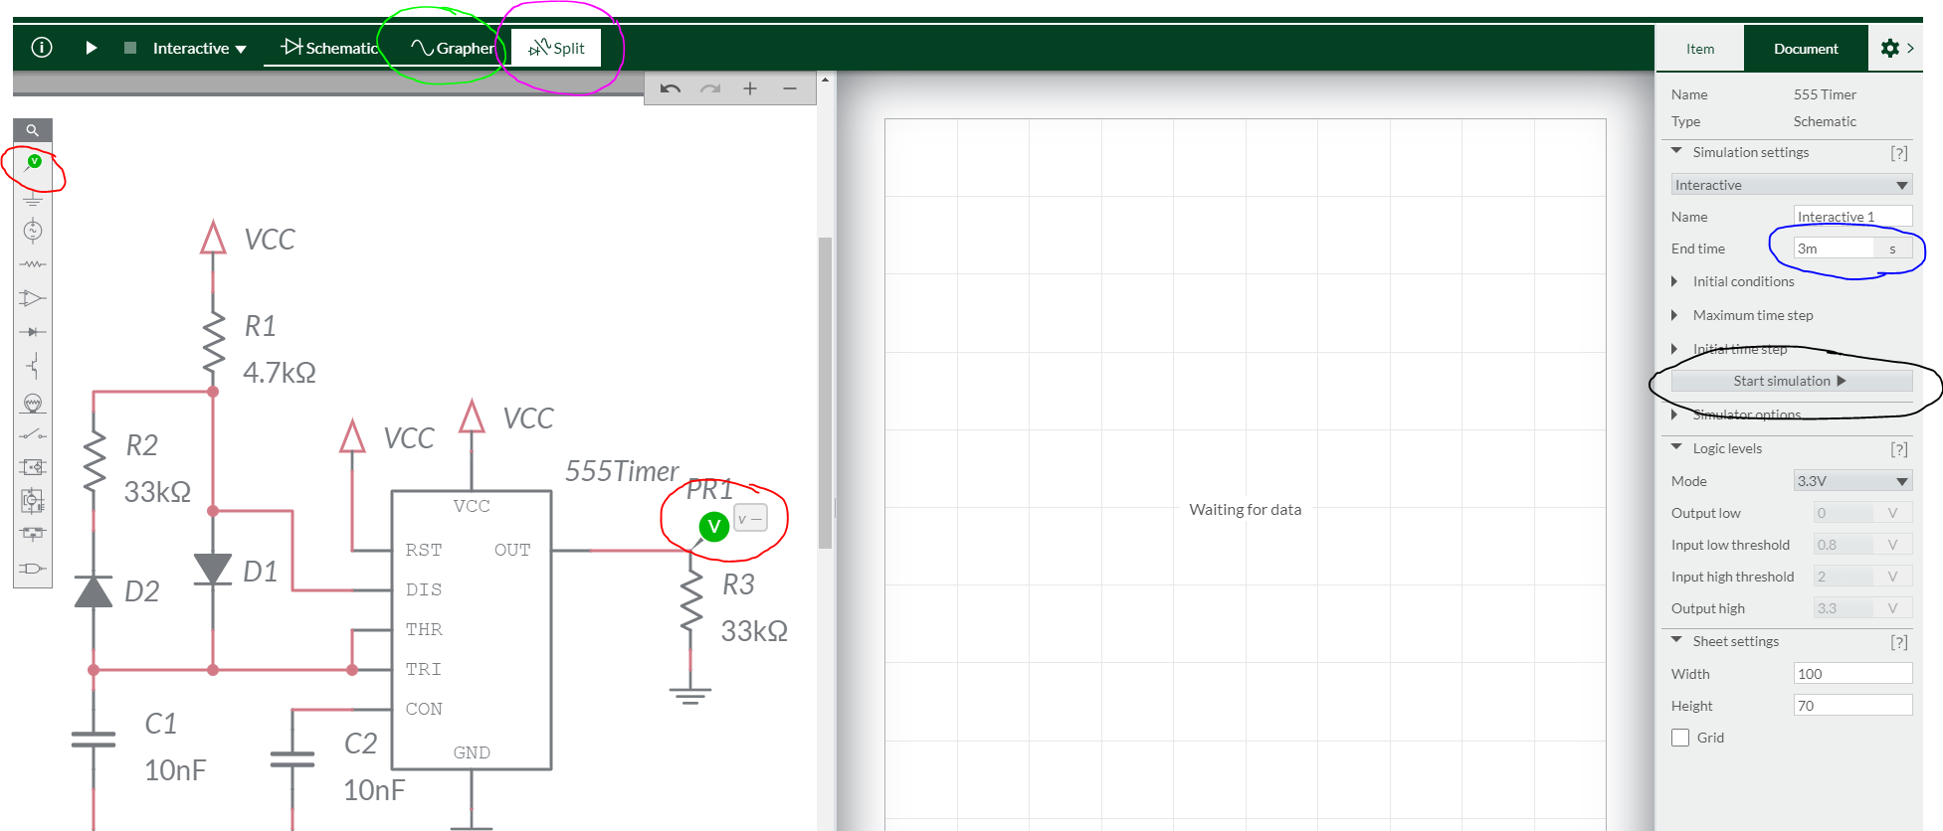

Figure : Setting up the 555-timer circuit for simulation.

1. You should now see a green trace showing the periodic waveform. If you get an error or not data, you have an error in your schematic; you will most likely have a missing or incorrect connection. Note that you can place multiple probes in your schematic, each one will have the same color as the probe in the schematic.
2. Click on the Grapher control (circled in green in Figure 6) to show the timing window as full screen.
3. Click on Zoom all (circled in red in Figure 7) to see the entire timing diagram.

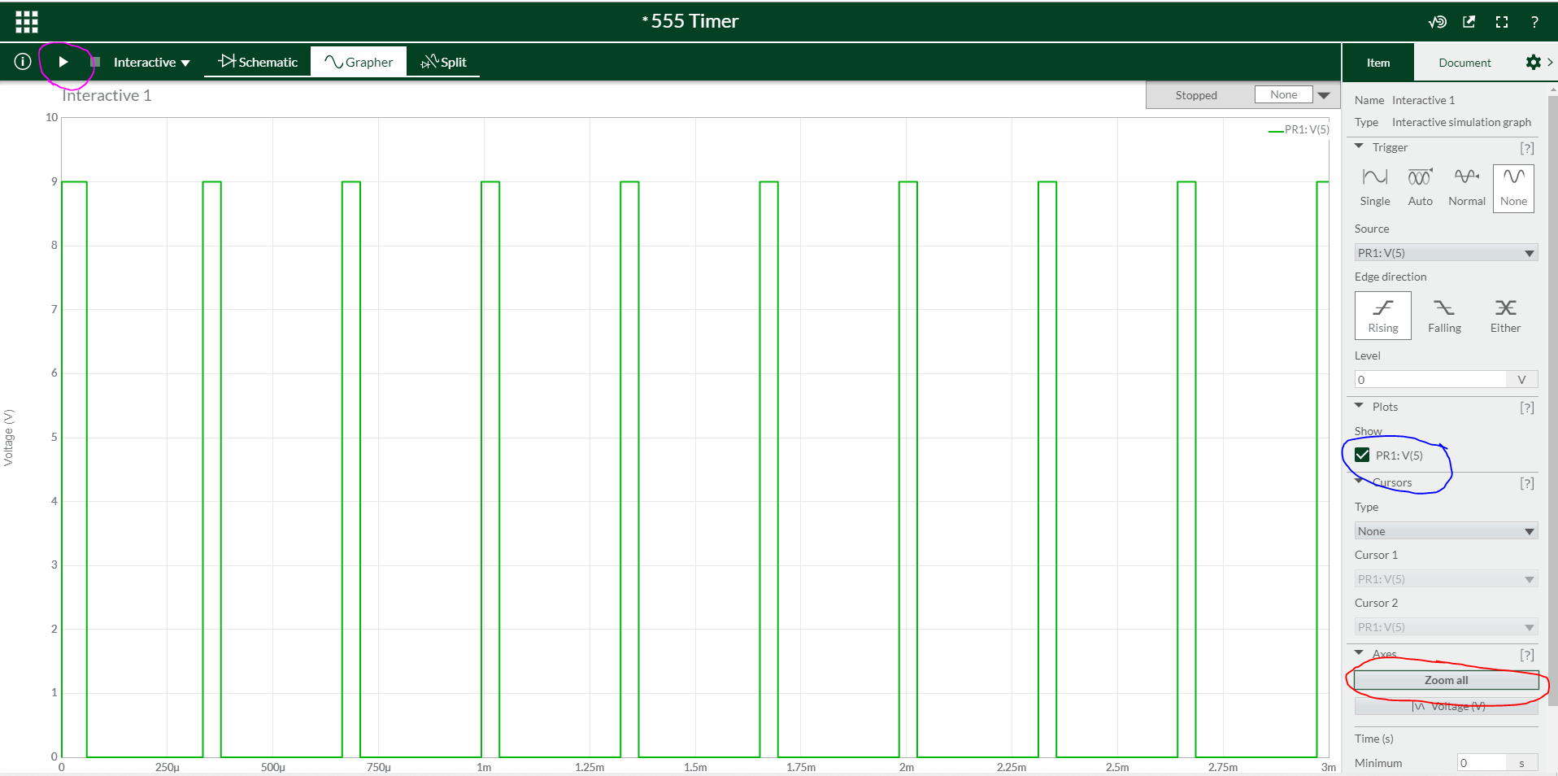

Figure : The Grapher shows the timing diagram of all the probes places in the schematic.

1. You can place the cursor on the horizontal and vertical axis and move the mouse center scroll wheel to zoom in and out on each axis. Left clicking and dragging allow you to translate across the axis. These two manipulations are handy when you want to focus on the details a waveform.
2. Add a probe on the schematic to measure the voltage of the capacitor. Use the property menu to change the ID of this probe to “cap”. Change the name of the probe attached to the out pin of the 555-timer to out.
3. Rerun the simulation (you can on the play button in the upper left corner of the screen).
4. Zoom in so that one wavelength (after the initial startup transients are over - around 2ms) of the out is more than half the vertical and horizontal area of the graph. You can use the Cursor option in the Item tab to measure times or voltages on the simulation output.

# Appendix A: Setup a Multisim Live premium account

If you already have a Multisim account, you can jump to step 2.

1. Go to https://www.multisim.com/
   1. Click on the yellow “SIGN UP” button,
   2. Enter your personal information on the “Create an NI User Account”,
   3. Click “CREATE ACCOUNT”,
   4. Go back to the www.multisim.com and signin .
2. Enable Premium
   1. Log into: <https://download.mines.edu/>,
   2. Login with your Mines credentials ,
   3. Look for the NI LabView Student Install Serial Number. This is the Multisim serial number asked for in a next step,
   4. Back in your multisim browser page, navigate to your Profile Settings,

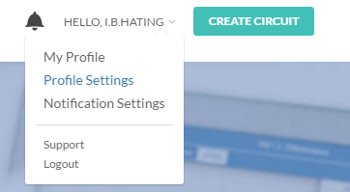

* 1. Enter your Multisim serial number in the New Serial Number field,
  2. In a few moments, the serial number should be verified,

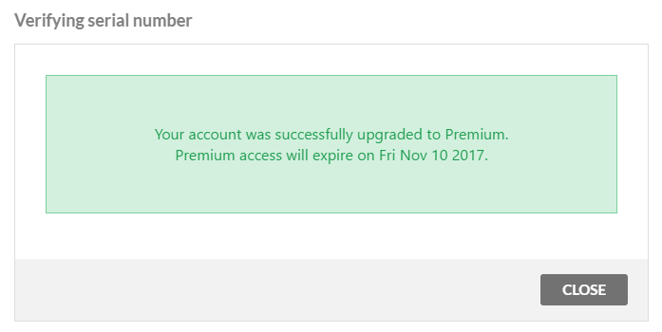

1. Congrats, you will not have to do this for the remainder of the term.